NAKUM ALOM:
Age : 14
Sex : Male
Group : KBMY EMAUS
Tribe : Amungme/Damal
Student of : Junior Public High School of Timika, grade 1
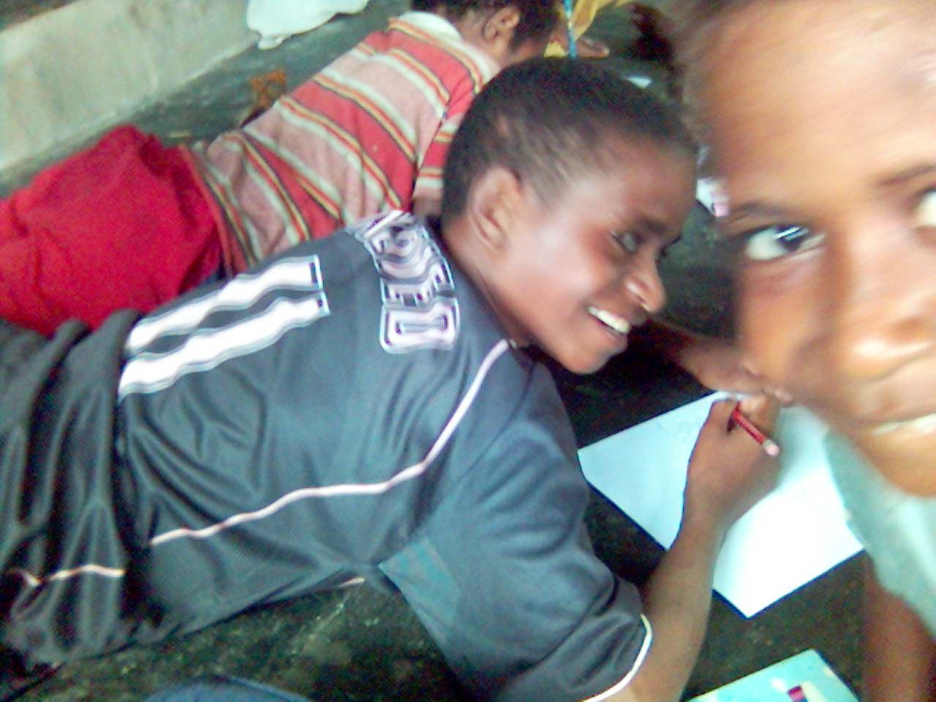
This small, happy, smiling, smart and industrious boy who makes friends easily, and acts as an interpreter for his newly found friends from the small villages that do not speak Indonesian yet, joined KBMY from the time he was still in the third grade of Elementary School Kwamki Lama, back in the beginning of 2001. He is the boy wearing a black soccer-shirt in the picture. Both his parents have since passed away, and he now lives with his uncle. The boy, who is somewhat smarter than the other children, is a better student compared to the others, and is intelligent, always comes out at the top of his class. Even for the final Elementary exam he finished as best of his class in writing. Nakum has since graduated from the Elementary School and is now studying at a Junior High School of Timika, having succeeded in beating more or less 200 other contestants in the school’s admission test, together with three other Papuan children that were admitted as well. KBMY proudly takes part in paying for Nakum’s tuition fees, consisting of the admission fee and monthly school committee fees. The boy’s ambition is to become a teacher, having thus been inspired by KBMY’s teachers who give instruction at the place where he lives. He hopes that way he will be able to help his juniors in becoming good students and achieve success.

MARNI & ELFIRA
Age : 13 and 15
Sex : Female
Group : KBMY SION
Tribe : Nduga
Students of : Junior High School YPPGI Kwamki Lama, grades 1 and 3

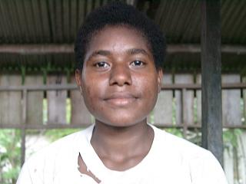
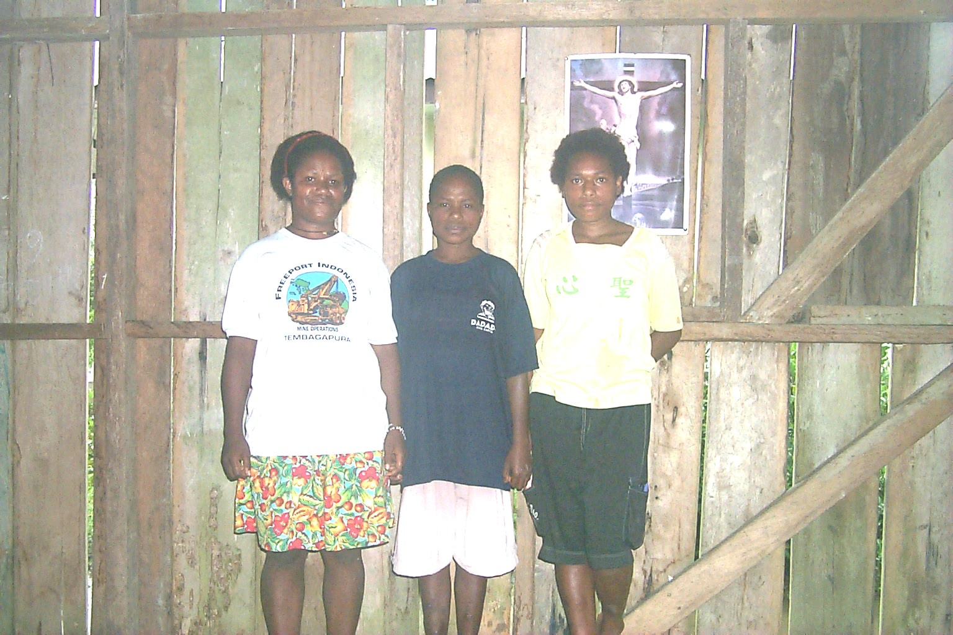
The two siblings joined KBMY at the end of the year 2000, when they were still in the third and fifth grades of Elementary School Inpres Kwamki Lama. Elfira is in the top picture, and Marni is in the bottom-right picture. In order to earn a living, they too, like most of the other children in Kwamki Lama, often help their mother with planting crops, taking the harvest to the local market in Kwamki Lama and finally selling it there. In spite of this they never failed to attend KBMY classes each Monday, Wednesday and Friday.
Ever since they joined KBMY they have become smarter and have left behind their friends, who are not students of KBMY. Presently they are in the first and third grades of the Junior High School, and though they have since left KBMY, their presence throughout the whole 5 years in this study group has been successful in establishing a long-term improvement, socially and academically. This is proven by the fact that they recently finished first (Elfira) and third (Marni) of their classes.
The girls have grown into two teenagers who no longer are in need of the kind of instruction they formerly received at KBMY, but require something different now, e.g. English language instruction and computer training. It is their hope that in the not too far future KBMY will be able to open courses in English language and computer usage in Kwamki Lama.

