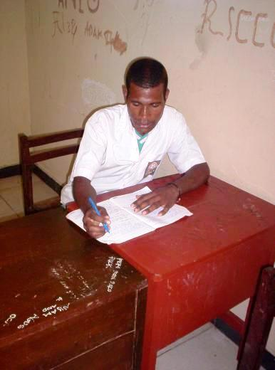
Esau's story:

I was born in Yeimu just outside Holuwon. After doing my basic schooling in Holuwon and Wamena I moved to Sentani in the year 2000 to pursue training at technical school.

My parents, being nothing but simple farmers could not assist me with schooling. In fact none of my family could because in the bush it is very hard to find money. What you grow you cannot sell because no one has cash. So, to pay for school I had to work it out myself. So, I would go around town asking if anyone needed odd jobs done. Sometimes I cut grass, sometimes I helped with construction - whatever people needed, I did.

Sometimes kind people would give me a bit of money here and there to help but mostly I was on my own. Most days I ate once a day and was always hungry. It was hard to concentrate at school because I was hungry and because I had to work so hard all the time just to find money. Then PEP came along! Now I don't have to work so hard doing odd jobs. I eat a lot better now with 2 meals a day and I rarely go hungry. I can concentrate on school and my grades are improving. Now I can even dare to dream about university. Maybe I can go after all!

My only real concerns now is the bus money I have to pay out to go back and forth to school - my school is half way between Sentani and Waena (where the two dorms are).

I am so grateful to PEP. Thank you and God Bless.

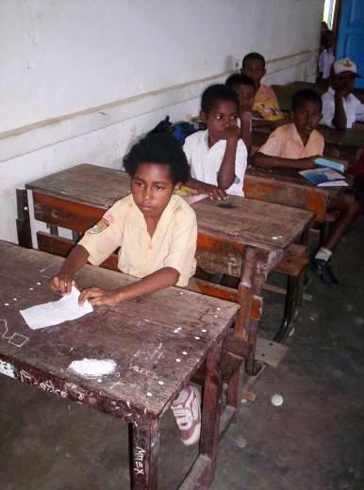
Yotamina's story related by her father:

I liked school, but my parents had little money, so it looked like we were going to drop out. My dad was in school too, so it was very hard, but then PEP came and started helping us. I am only in grade school, but I hope now I can go to junior high and high school. Maybe I can be the first girl to get a S1 (BA).

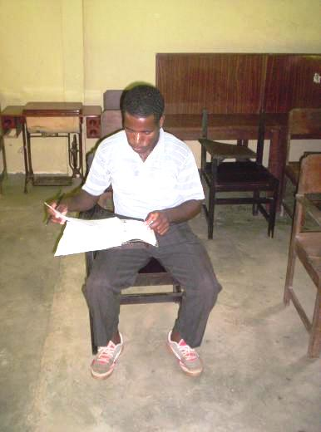
Demius's story:

I was born in Una, a small village outside Holuwon. I did school in Holuwon and then went to theology school in Nabire. When I was done I went back to Holuwon to work with the church, but they encouraged me to pursue higher education. A friend recommended the Baptist theology college in Abepura near Sentani.

I could not afford it, but my friend told me I must trust God so I went on faith. Ever since I was small I knew I must do this because when I was 8 my last parent died and I was an orphan. My oldest sister raised me and she told me I must serve God and to do that I need education. God spoke to me and told me that he was calling me, so since I was 8 I knew what I must do.

I started school and had no money, but the head master saw I was determined and he helped me. After that I found money by going fishing in the local lake and selling the surplus for money. What I did not sell, I ate. I also built a garden and sold produce for school money. Of course I ate some of that too.

It was right at this point that PEP arrived with help. I am so grateful. Now the food I catch I can share with my friends and we just focus on school. Life has gotten a bit easier and my grades are improving (NOTE: He has the highest GPA of all our kids!)

I hope to keep going to school and complete my S1 (BA).

Thank you PEP and God Bless

